

**硕士研究生学位论文**

**开题报告**

**Proposal Report of Graduate Student Degree Thesis**

**Thesis Title:** Sound Vibration and Shell Structures

with Internal Sound Field

**College:**  Maritime College

**Major:** Civil and Hydraulic Engineering

**Research Field:** Marine Engineering

**Name:** Zhao Tian

**Student ID:** 2011097000

**Supervisor:** Chen Yue

**Enrollment Date:** 2020.09

Ningbo University Maritime College

July 2024

**Instructions for Master's Thesis Proposal**

1. The Master's thesis proposal is fundamental to the preparation of the thesis. To improve the management system of the Master's degree process and enhance the quality of Master's degrees, the thesis proposal should generally be completed by the end of the third semester.

2. The proposal should be completed by the graduate student under the guidance of their advisor (or advisory committee). The literature review in the proposal should be clearly categorized, reasonably summarized, accurately identifying scientific and technical issues, logically organized, fluently written, and with standardized charts and tables. The proposal should be no less than 10,000 words, including approximately 6,000 words for the literature review. At least two-thirds of the references should be from the past five years. Fabrication and plagiarism are strictly prohibited.

3. Based on extensive review of domestic and international literature, the student should complete the "Master's Thesis Proposal" form. After approval by the advisor, an open thesis proposal meeting should be held within the discipline or related disciplines.

4.The proposal meeting is organized and implemented by the admitting discipline. The proposal review committee is responsible for providing conclusive review comments and submitting the results and related materials to the college for record. The review committee should consist of 3 to 5 experts in the relevant discipline, including a chair and a secretary. The chair must be an expert with a senior technical title. The inclusion of one external expert is encouraged. The applicant's advisor cannot be a member of the review committee. Teachers and students from the same field may be invited to attend and provide feedback.

5. The "Master's Thesis Proposal" must be printed double-sided on A4 paper, bound on the left side. If the space in any section is insufficient, please add additional pages as needed.

**Table of Contents**

1 Background, Objectives, and Significance of the Thesis Topic 1

1.1 Background 1

1.2 Research Objectives 2

1.3 Theoretical Significance 2

1.4 Practical Application Value 3

2 Current Research Status and Development Trends 4

3 Research Content and Problem Description 9

3.1 Research Content 9

3.2 Problem Description 10

4 Research Plan 12

4.1 Research Methods 12

4.2 Technical Route 13

4.3 Feasibility Analysis 13

4.4 Anticipated Challenges and Solutions 14

5 Innovation Points 16

6 Expected Achievements 17

7 Thesis Outline and Work Plan 18

7.1 Thesis Outline 18

7.2 Dissertation Work Plan 19

References 20

# 1 Background, Objectives, and Significance of the Thesis Topic

## 1.1 Background

Complex shell structures based on plate and shell structures, as a common mechanical combination structure, are applied in engineering fields such as aviation, aerospace, shipbuilding, underwater structures, and civil engineering. In aerospace engineering, aircraft fuselage, spacecraft structural components (as shown in Figure 1.1), missile and satellite casings, and aircraft engine casings; Large span roofs, arch dams, blast furnace main bodies, power plant cooling towers, elevated water towers, underground structures and tunnels in the field of civil engineering and architecture; Oil storage tanks (as shown in Figure 1.2), refining equipment, and pressure vessels such as oil pipelines in the petroleum and petrochemical industry; The main structures of atomic reactors and particle accelerators in the nuclear industry widely use shell structures or their combination forms.

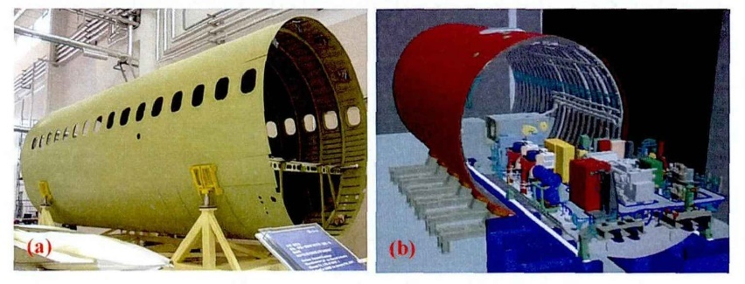 

Figure 1.1 Aircraft cabin and spacecraft structural components



Figure 1.2 Storage tank

Especially in marine engineering, hull based cabin structures are widely used in many military and civilian equipment, such as ship cabins, submarines, submarine launched missiles, and other underwater vehicles. The above mechanical equipment is mostly connected by many typical mechanical structural components, such as end faces, flat plates, cylindrical shells, etc., through welding, riveting, and bolt connections. Due to the operation of the propeller in an uneven wake field, periodic axial thrust will be generated on the blade, causing longitudinal vibration of the propulsion shaft system. The shaft system, as the main transmission path, transfers the pulsating thrust generated by the propeller and underwater wake field to the interior of the coupled cabin structure, causing longitudinal excitation force to be transmitted to the coupled structure, thereby causing vibration of the cabin and hull. This not only damages the physical and mental health of personnel, but also causes fatigue damage to the structure, resulting in significant accidents.

## 1.2 Research Objectives

At present, the analysis of the acoustic vibration characteristics of complex shells in specific environments in China mainly focuses on the vibration acoustic radiation problem of underwater submarines. The free vibration characteristics of complex coupled structures and the acoustic characteristics of the internal sound field are the basis for studying the acoustic radiation, component fatigue, and dynamic response of the entire system. Each compartment in the submarine is divided into two or several layers, and the acoustic design of each space is the basis for determining the high-performance and low-energy operation of these equipment. There are open clamping plates between each layer, and personnel or materials enter and exit through these openings. These openings not only change the original vibration characteristics of the complex shell, but also change the acoustic characteristics. The impact on the entire system cannot be ignored. At present, scholars both domestically and internationally focus more on studying the vibration characteristics of individual components, such as rectangular plates, circular plates, cylindrical shells, and other structures, with little attention paid to the impact of open plates on the vibration of the entire underwater vehicle structure. At the same time, there is little research on the acoustic characteristics of its internal irregular sound field, and there is even less research on the acoustic vibration coupling system of complex shell structures with internal sound fields. In practical engineering, complex shell coupling systems with internal sound fields are generally composed of cylindrical shells, rectangular plates, end plates, and two irregular sound chambers.

In summary, further research is needed on the sound vibration characteristics and sound radiation mechanism of complex shell structures with internal sound fields. Therefore, conducting research on the acoustic vibration characteristics and acoustic radiation mechanisms of complex shell structures with internal sound fields has significant engineering guidance significance.

## 1.3 Theoretical Significance

(1) Enriching sound vibration theory: The study of sound vibration and sound radiation mechanisms in complex shell structures with internal sound fields will help enrich and improve existing sound vibration theories, especially in the coupling of complex structures and sound fields. By deeply analyzing the vibration behavior and acoustic radiation characteristics of shell structures in the sound field, more details about the coupling mechanism of sound and vibration can be revealed, promoting the development of relevant theories.

(2) Improving the accuracy of computational models: Studying the sound vibration and radiation mechanisms of complex shell structures can help establish more accurate computational models. These models can not only improve the accuracy of existing simulation tools, but also provide a theoretical basis for developing new simulation algorithms.

(3) Guiding design optimization: By gaining a deep understanding of the sound vibration and radiation mechanisms of complex shell structures, theoretical guidance can be provided for engineering design, especially in structural optimization and material selection. This will help design shell structures with better acoustic performance, reducing unnecessary noise and vibration.

## 1.4 Practical Application Value

(1) Improving noise control: Studying the sound vibration and radiation mechanisms of complex shell structures with an internal sound field can provide effective solutions for noise control. In industries, transportation, construction, and other fields, optimizing shell structure design can reduce noise pollution and improve environmental quality.

(2) Improving product performance: Complex shell structures are widely used in high-end manufacturing industries such as aerospace, automotive manufacturing, and marine engineering. By studying its sound vibration and radiation mechanisms, design can be optimized, product performance and reliability can be improved, and market competitiveness can be increased.

(3) Promoting the application of new materials: This research can provide data support and theoretical basis for the development and application of new materials. For example, research results can guide the application of new composite materials in complex shell structures, thereby achieving better acoustic performance and structural strength.

(4) Improving comfort and safety: Reducing noise and vibration is crucial for enhancing comfort and safety in transportation and building structures. By studying the sound vibration and radiation mechanisms of complex shell structures, more effective noise reduction and vibration reduction measures can be proposed to enhance user experience and safety assurance.

# 2 Current Research Status and Development Trends

In elasticity, a flat continuum with a plane as its midplane is called a flat plate, and an elastic continuum enclosed by two curved surfaces is called a curved shell. If the curvature of the curved shell surface is zero everywhere, the flat plate can be regarded as a special shell. Curved shells can be divided into three categories based on the Gaussian curvature of the middle surface of the shell: positive Gaussian curvature shells include spherical shells, ellipsoidal shells, etc., zero Gaussian curvature shells include cylindrical shells, conical shells, etc., and negative Gaussian curvature shells include single leaf hyperbolic spherical shells. The study of plate and shell vibration problems has a history of over 200 years, forming numerous theories, including classical plate and shell theory, first-order shear deformation theory (FSDT), high-order shear deformation theory (HSDT), and three-dimensional elastic theory.

This section will comprehensively discuss the development and current status of domestic and foreign research on the paper's work, mainly including the research progress of three types of structural vibration problems: flat plate structures, cylindrical shell structures, and plate shell coupling structures.

According to the classical theory of shell and plate, a thin plate is called a thin plate when its thickness is much smaller than the size of the mid plane. The flat plate mainly bears the transverse load on the vertical plane and transfers the external load to the support. At this time, the plate undergoes transverse deflection on the vertical plane, and the corresponding dynamic problem is the transverse vibration of the thin plate. When a flat plate is subjected to an in-plane load, if there is no lateral external load present simultaneously, it belongs to an in-plane vibration problem. If a lateral load is applied simultaneously, the in-plane load will affect the lateral vibration. There are three forms of vibration in plate structures. Namely: bending wave, longitudinal wave, and shear wave. Among these three waveforms, bending wave is often referred to as out of plane vibration, and because longitudinal wave and shear wave are in the plane where the structure is located, they are also collectively referred to as in-plane vibration. For many years, scholars at home and abroad have conducted extensive research on the bending vibration characteristics of thin plates.

The study of flat plate theory began with Leonhard Euler's study of the vibration of thin films in 1766. He believed that the thin film is composed of strings that are perpendicular to each other and tensioned, and obtained a simplified differential equation for the lateral vibration of the thin film. In the early 19th century, E.F.F. Chiladni cleverly studied the vibration of the board by laying fine sand on the surface. By utilizing the motion of fine sand, he discovered the vibration mode and corresponding frequency of the board. In 1876, Kirchhoff conducted relevant research on the bending of plates and derived the hypotheses of straight normals and perpendicular to the midplane, which greatly promoted the study of plate and shell theory. At the end of the 19th century, Love proposed the first approximation theory based on the assumption of small deformations in thin shell structures. The successive proposals of Kirchhoff theory and Love theory have greatly promoted the formation of classical plate and shell theory.

After conducting extensive research and summary on the vibration problems of plate structures, American scholar Leissa [2] wrote the book "Vibration of Plates", which is a famous reference material for studying the bending vibration of thin plates. Navier and Levy respectively studied the bending problems of thin plates with four simply supported rectangular plates and two simply supported rectangular plates with opposite edges, making groundbreaking contributions to the theory of thin plate bending. Navier expanded the bending deflection of the plate into a double sine series and obtained an accurate solution for the bending problem of simply supported rectangular plates on four sides. He also solved the bending problem of rectangular plates under uniformly distributed loads and concentrated loads at the center of the plate. Levy used a single sine Fourier series to solve the bending problem of a rectangular plate with two opposite edges simply supported and the other two edges arbitrarily supported. After entering the 20th century, Ritz [3] proposed the variational method for solving the bending problem of thin plates. After this method was proposed, the bending and vibration problems of various shapes of thin plates, such as rectangular and circular thin plates, can be solved through the perspective of energy. The prerequisite for applying the Ritz method is to know the total potential energy, that is, to know a functional. However, in solving thin plate problems, sometimes only differential equations can be obtained, and functional functions are difficult to obtain, which makes the problem difficult to solve smoothly. To solve this problem, Galerkin [4] modified the Ritz method and proposed to obtain approximate solutions only from differential equations. The basis of Galerkin's method is the principle of virtual work, which means that the force of an equilibrium system does zero work in the direction of virtual displacement. It can be said that the Galerkin method is a further development of the Ritz method, which has expanded the application range of the Ritz method. Timoshenko [5] conducted in-depth research on the stability problem of thin plates under compression and applied the Ritz method to calculate the final deflection of the thin plate boundary under the action of force couples. Later, it was confirmed that the accuracy of this solution had reached a high level.

At present, the vibration research methods of flat plate theory mainly include analytical method, energy method, and numerical method. The analytical method has attracted the attention of many scholars due to its clear mathematical model, rigorous theoretical derivation, and providing a theoretical basis for numerical solutions. The Navier solution and Levy solution are obtained through analytical methods. Wang [6] used this method to analyze the exact frequency relationship of simply supported rectangular plates on four sides under Mindlin theory and Kirchhoff theory, combined with the explicit equation. At the same time, he also provided the relationship between the frequencies obtained from parallelogram plates, circular plates, and sector plates under these two theories. Hashemi et al. [7] derived the bending vibration of rectangular plates using dimensionless equations without using any approximate methods. They provided accurate solutions to the vibration characteristic equations under six types of combined supports and analyzed the effects of boundary conditions, aspect ratios, and thickness ratios on the vibration eigenfrequencies and modal characteristics. Endo et al. [8] combined Hamilton's principle and used bending variables instead of turning angles as the basic variable, and overall deformation as the accompanying variable to derive the vibration control equation and boundary conditions of elastic plates. Xing et al. [9] used the method of separating variables to derive characteristic equations for three different boundary conditions and obtained closed form solutions for the free vibration of rectangular plates. Wen L.L. [10] added artificial springs to the thin plate boundary to simulate the shear stress and bending moment of four boundaries, and different boundary conditions can be obtained by setting different stiffness values of the artificial springs. He represented all displacement functions as a sum of a double Fourier series and multiple auxiliary residuals, and then substituted them into the control differential equation to obtain a semi analytical solution for the bending vibration of thin plates.

The energy method describes the equilibrium state and geometric deformation conditions of a system through the principle of energy. Due to its good integrity and simple solving process, it has also been applied in plate and shell vibration. Common energy methods include Rayleigh Ritz method, Kantorovich method, etc. The Rayleigh Ritz method, based on the principle of minimum potential energy, relaxes the satisfaction of the differential equation of the deflection surface after accurately satisfying the displacement boundary conditions, thereby obtaining an approximate solution to the problem [11]. Park and Hong [12] introduced displacement potential functions to decouple the differential equations of in-plane motion of plate structures, and obtained the equations of longitudinal wave and in-plane shear wave motion, respectively. They studied the distribution law of energy flow in coupled plate structures. Bercin and Langelyb [13] studied the in-plane vibration of plate structures using dynamic stiffness techniques and calculated the vibration response of a simplified model of a ship base composed of seven rectangular plates. They compared the energy distribution at different response positions when considering in-plane vibration. Bardell et al. [14] studied the in-plane vibration of plates using the Rayleigh Ritz method and provided a valuable review of the literature to date. Al Bermani et al. [15] used two-dimensional polynomials and fundamental functions as deflection functions, combined with the Rayleigh Ritz method, to analyze the free vibration of arbitrary quadrilateral structural plates.

There are two commonly used methods in numerical methods, one is finite difference method and the other is finite element method. The so-called finite difference method is a numerical solution that replaces differential equations and corresponding boundary conditions with a set of finite difference equations. It transforms the boundary value problem of difficult to solve differential equations into an easily solvable algebraic system of equations problem. In today's rapidly developing computer world, the finite difference method has significant practical significance. The finite element method, as an effective computational tool, is increasingly being used to solve plate and shell vibration problems. McGee et al. [16] used quadrilateral isoparametric elements to provide dimensionless frequencies and modes of vibration for cantilever plates with different thickness ratios and slopes, and analyzed the vibration characteristics of parallelogram plates under cantilever boundary conditions. Sheikh et al. [17] derived a high-precision triangular element with a node at each vertex and the midpoint of the three sides, and analyzed the vibration of the plate structure using a concentrated mass matrix.

The Differential Quadrature (DQ) method, as a numerical solution, was initially used to solve initial and boundary value problems. It has the advantages of simple mathematical formulas, low computational complexity, and high accuracy, making it an effective numerical algorithm in engineering analysis. Wang et al. [18] attempted to use the roots of Chebyshev polynomials as node coordinates and transform the control equation through an oblique reference axis. For the first time, they analyzed the buckling and free vibration problems of parallelogram thin plates with simple and fixed boundary conditions using differential quadrature method.

The research on the vibration characteristics of flat plates started relatively late in China, but there are still many achievements that have emerged. Starting from the differential equation of free vibration of thin plates, Fang Yingwu et al. [19] studied the dynamic characteristics of lateral free vibration of thin plates using the boundary element method (BEM) based on the theory of elastic thin plates and vibration theory. Zhang Yuanyuan et al. [20] conducted finite element analysis on the vibration of rectangular thin plate structures using MATLAB software, and studied the steady-state response of the thin plate under different boundary conditions of free vibration and harmonic excitation force. Huang Yan [21] established a general solution for the differential equation of the transverse free vibration configuration function of rectangular thin plates, which is used to solve the vibration problem of rectangular thin plates with arbitrary boundaries. Xu Qiang et al. [22] proposed a new algorithm for solving the free vibration problem of thin plates based on the concept of virtual boundary element method. By using the static basic solution of the bending problem of thin plates, the virtual boundary integral equation of the free vibration problem of thin plates was established, and the boundary conditions and dynamic displacement equation of points in the domain were satisfied. The free vibration problem of thin plates was transformed into an algebraic eigenvalue problem for solution. Qin Yafei et al. [23] proposed an element free method for analyzing the free vibration problems of four sided simply supported and four sided fixed thin plates. Bao Siyuan et al. [24] introduced the problem of free vibration of elastic thin plates into the Hamiltonian dual system, simulating the x-direction as time, selecting bending moment, equivalent shear force, rotation angle, and deflection as dual vectors, and obtained analytical solutions for symmetric and antisymmetric x-axis under different boundary conditions. Zhong Yang [25] expressed the dynamic equation of an elastic rectangular thin plate as a Hamiltonian canonical equation, and then used the symplectic geometry method to separate the variables of the full state phase variables. Using the obtained conjugate symplectic orthogonal normalization relationship, the analytical solution expressions for the natural frequency and vibration mode of the four sided fixed supported elastic rectangular thin plate were obtained. Yao Benyan et al. [26] proposed an element division combination research method for the vibration and sound radiation characteristics of reinforced thin plates. A unidirectional symmetric reinforced rectangular thin plate with four simply supported edges was taken as the research object. The thin plate was divided into two simple elements along the reinforcing ribs, and the effect of the reinforcing ribs was equivalently applied to the thin plate using the reaction force method. The vibration characteristics of the reinforced plate were studied using the continuity conditions of the elements. Shen Peng et al. [27] used tensor product to construct two-dimensional Hermite wavelet interpolation functions for solving thin plate vibration problems. Wang Xiaojun et al. [28] constructed an equivalent system of rectangular plates with simple support, fixed support, or a combination of two boundary conditions, making the stiffness matrix a cyclic matrix. By using the U-transform, the finite element matrix equation was successfully decoupled, making finite element calculations only need to be carried out on one element, expanding the scope of the U-transform finite element method for analyzing elastic rectangular thin plates. Jiang Shiliang from Harbin Engineering University [29] used spectral geometry to analyze the vibration characteristics of straight quadrilateral thin plates and open thin plates.

# 3 Research Content and Problem Description

## 3.1 Research Content

#### (1) Research on Free Vibration Characteristics of Irregular Shaped Plates and Composite Materials Plates under Arbitrary Boundary Conditions

Irregular shaped plate structures are widely present in various industries, such as shipbuilding, aerospace, civil engineering, and construction. Most studies have been conducted on the vibration problem of rectangular plates both domestically and internationally, while there is relatively little research on the problem of irregular shapes. So it is necessary to establish a mathematical model for irregular shaped plates and their free vibration characteristics, which provides a theoretical basis for solving related practical engineering problems.

Based on the energy functional method, establish a mathematical model for the free vibration of irregular shaped plates under arbitrary boundary conditions. Introducing the Chebyshev series method, using Chebyshev polynomials to represent the displacement function of an open plate, and using displacement springs and rotating springs to simulate any boundary conditions. When dealing with irregular shape problems, the divergence theorem is introduced to convert irregular domain integration into line integration. For irregular polygons, domain integration can be transformed into corner summation. Based on Kirchhoff theory and first-order shear deformation plate theory, a Lagrangian energy functional equation is established. The unknown Chebyshev expansion coefficients are taken to extreme values, and a generalized characteristic matrix equation is obtained. By solving the characteristic equation, the natural frequency and corresponding vibration mode of irregularly shaped plates can be obtained.

Build a vibration test platform for plates of any shape to conduct frequency response and modal tests. By comparing and analyzing the numerical calculation structure with ANSYS simulation results and experimental structures, the accuracy and effectiveness of the method proposed in this paper are verified. Simultaneously analyze the impact of geometric shape changes on the natural frequency. For laminated fiberboards, analyze the impact of changes in ply angle on the natural frequency and vibration mode.

#### (2) A Study on the Free Vibration Characteristics of Periodic Ring Ribbed Cylindrical Shells under Arbitrary Boundary Conditions

Cylindrical shell structures are widely present in various industries, such as aircraft fuselage, ship compartments, and submarine hull. The research on the vibration characteristics of cylindrical shells is becoming increasingly sophisticated, but there is relatively little research on reinforced cylindrical shells and periodic cylindrical shells. The periodicity of the structure can lead to bandgap phenomena, where the vibration response is particularly small within a certain frequency range. Therefore, conducting this research is meaningful.

For periodic cylindrical shell structures, based on the energy functional method, boundary springs are introduced to simulate Bloch's theorem. For finite cylindrical shells, domain decomposition method is used for modeling and solving. At the boundary of cylindrical shell cylindrical shell coupling, a uniformly distributed spring group is used to describe the coupling conditions, and four effects, including bending moment, transverse shear, in-plane shear, and longitudinal shear, are comprehensively considered at the structural connection. Introduce the form of Chebyshev series and Fourier series as the trial function for cylindrical shells. Introducing the divergence theorem to transform irregular domain integration into line integration,. Based on the theory of thin shells, a Lagrangian energy functional equation is established. The unknown Chebyshev expansion coefficients are taken to their extreme values, and the generalized characteristic matrix equation is obtained. By solving this equation, the natural frequencies and modes of vibration of periodic cylindrical shells are obtained. Finally, the results of programming calculations will be compared with those of ANSYS simulation calculations to verify the accuracy and effectiveness of the method proposed in this paper. Then perform parametric analysis. Analyze the effects of changes in reinforcement geometry and material parameters.

Build a densely reinforced cylindrical shell test platform for frequency response analysis and modal testing.

#### (3) Research on Free Vibration Characteristics of Circular Plate Rectangular Plate Cylindrical Shell under Arbitrary Boundary Conditions

Although cylindrical shell structures are widely used in the engineering field, in many cases, using a simple cylindrical shell model to describe the actual structure appears too simplified and unreasonable. In order to make the established analysis model more realistic, it is often necessary to consider the strengthening forms of cylindrical shells such as reinforcement, ribs, and double-layer, and even the structural coupling forms of cylindrical shells with partitions or end plates. In the fields of ships, aerospace, and other fields, coupling structures such as rectangular plates cylindrical shells are commonly present. Therefore, in the study of circular plate rectangular plate cylindrical shell coupling structures, establishing a reasonable and complete mathematical and physical model is conducive to revealing the dynamic behavior of various plate shell coupling structures in detail and at a deep level.

On the basis of completing the first and second parts, establish a vibration model of complex shell structures under arbitrary boundary conditions. At the boundary of plate cylindrical shell coupling, a uniformly distributed spring group is used to describe the coupling conditions, and four effects, including bending moment, transverse shear, in-plane shear, and longitudinal shear, are comprehensively considered at the structural connection. Solve the differential equation of coupled structural vibration using energy functional, perform modal analysis, and compare the MATLAB calculation results with the ANSYS workbench platform simulation results to verify the accuracy of the method proposed in this paper. Simultaneously analyze the impact of changes in the position of the flat plate on the vibration characteristics of the entire structure.

Design a plate shell coupling structure, build the experimental platform, and conduct response and modal tests。

## 3.2 Problem Description

Through extensive reading of literature, it can be found that there is still relatively little analysis of the acoustic vibration characteristics of complex shells, irregular sound fields, and complex shells with internal sound fields. For the analysis of the acoustic vibration characteristics of complex shells with internal sound fields and the study of radiation mechanisms, several problems need to be solved: modeling methods for composite structures and irregular sound fields, structural sound coupling on irregular interfaces, cross coupling modeling between multiple structures and multiple sound fields, and energy dissipation mechanisms of sound cavities. A combination of theoretical research, numerical analysis, and experimental verification is used to conduct research. There are four main problems to be solved:

Firstly, analysis of vibration characteristics of complex shell structures. This study aims to solve the vibration modeling and characteristic analysis problems of arbitrarily shaped plate structures, ring-shaped cylindrical shell structures, and complex shell structures under elastic boundary conditions. At the same time, the vibration modeling results are verified through experiments to ensure the accuracy and reliability of the model.

Secondly, analysis of the acoustic field characteristics within the structure. This problem involves modeling and characteristic analysis of rectangular and cylindrical sound fields under arbitrary impedance walls, while studying the modeling and characteristics of irregular sound fields, and exploring the acoustic characteristics of structural sound field coupling systems to reveal the influence of complex boundary conditions on the sound field.

Thirdly, research on the characteristics of complex shell structure coupled systems with internal sound field. The focus of the research is to establish coupling system models between cylindrical shells and cylindrical sound fields, irregular sound cavities and arbitrarily shaped open plates, as well as irregular sound cavities, plates, and shells, analyze the coupling characteristics and acoustic vibration response of these systems, and reveal the influence of acoustic vibration coupling on system response.

Fourthly, the study of sound radiation from complex shells with internal sound fields focuses on the sound radiation models and radiation efficiency issues of cylindrical shells, complex shells, and their coupled systems. By studying the sound radiation characteristics of different structures and materials, accurate sound radiation models are established, and the radiation efficiency and sound radiation distribution characteristics of these models are analyzed.

# 4 Research Plan

## 4.1 Research Methods

On the basis of establishing a three-dimensional prediction theoretical model for complex shell structures and their internal noise, quantitative evaluation of sound energy and analysis of sound radiation characteristics are carried out. The research approach is shown in Figure 4.1.

In terms of quantitative evaluation of sound energy, the energy method is used to derive and establish a cabin structure sound field coupling model with non-uniform distribution of wall impedance. Based on Rayleigh integral, the mathematical and physical relationship between the surface vibration distribution of the coupling system structure and the external radiated sound field is established; Based on the theory of modal superposition, the coupling mode separation method between sound cavity and structure is studied. The sound energy distribution curve and cloud map of the sound cavity under the influence of parameters such as structural damping, air damping, and wall impedance are calculated. The energy dissipation characteristics of the sound pressure mode of the sound cavity under the condition of sound excitation energy are obtained. The influence of the sound pressure mode and structural vibration mode components of the sound cavity on the structural sound input energy under the same sound excitation energy input conditions is analyzed.

In terms of acoustic radiation characteristics analysis, explore the influence of various parameters such as plate stiffening, moment of inertia, number and spacing distribution of ribs, plate shell thickness, boundary constraints, and medium type on the radiated sound field; Starting from the vibration mode matrix, the modal normal velocity matrix and modal sound pressure matrix are defined, and a structural vibration mode analysis model based on the quadratic expression of radiated sound power is established. The acoustic field characteristic parameters such as structural modal radiation efficiency, structural radiated sound power, and radiation efficiency are solved under different conditions such as ribs. The influence of coupling between structural sound system modes on radiated sound power and the contribution of structural sound field modes to radiated sound power are analyzed; Establish a system radiation mode analysis model based on the quadratic expression of radiated sound power, calculate the radiation mode radiation efficiency and radiation mode shape of the system.

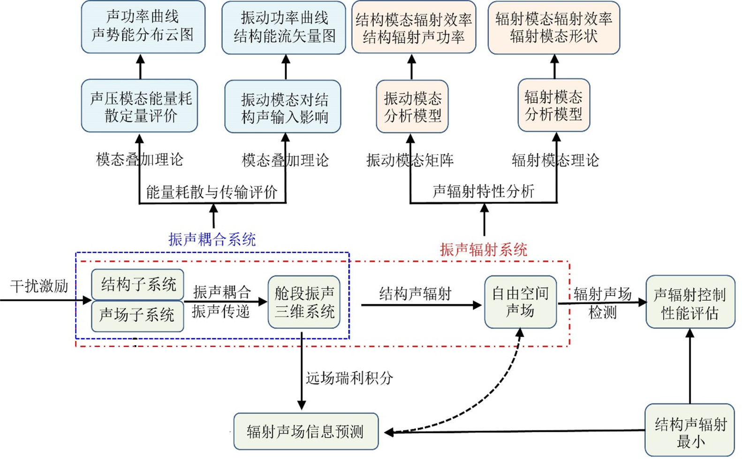

Figure 4.1 Research ideas on quantitative evaluation of internal noise energy in complex shells and far-field acoustic radiation models

## 4.2 Technical Route

The technical roadmap proposed for this paper is shown in Figure 4.2.

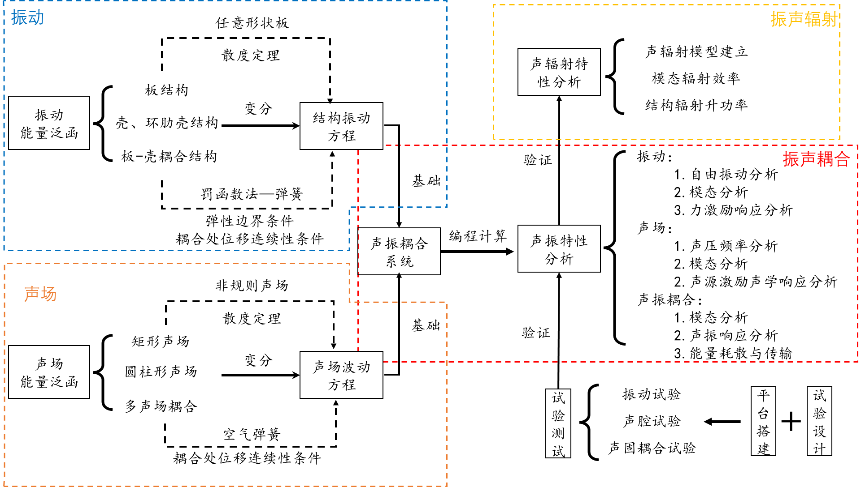

Figure 4.2 Overall research technology roadmap for the paper

## 4.3 Feasibility Analysis

I have a solid theoretical foundation and strong analytical abilities in acoustics, vibration, and structural mechanics. Through systematic course learning and project practice, I have mastered relevant calculation methods and experimental techniques. In addition, there is a strong interest and certain research experience in the study of acoustic vibration and radiation mechanisms in complex shell structures with internal sound fields. Under the guidance of my supervisor, I have participated in research on some related topics and accumulated some preliminary scientific research achievements and experience.

The laboratory has advanced experimental equipment and a complete experimental environment, which can provide strong support for the research of this project. The laboratory is equipped with high-precision vibration tables, acoustic testing systems, and data acquisition equipment, which can meet the needs of complex shell structure acoustic vibration and radiation experiments. The laboratory also reserves abundant experimental materials and has the ability to process and manufacture complex shell structure samples. In addition, the laboratory has multiple simulation calculation platforms, such as ANSYS and COMSOL, which can help me conduct accurate numerical simulations and analysis, improve research efficiency and accuracy. The basic resources of the laboratory provide a solid guarantee for my research.

In summary, based on one's own theoretical knowledge and research capabilities, as well as the basic resources of the laboratory, the study of the sound vibration and radiation mechanism of complex shell structures with internal sound fields has good feasibility.

## 4.4 Anticipated Challenges and Solutions

#### (1) Modeling and Analysis of Complex Shell Structures

Difficulty: The geometric shape and material characteristics of complex shell structures are complex, and traditional modeling methods are difficult to accurately describe their true physical characteristics, resulting in limited accuracy of vibration and sound radiation analysis results.

resolvent:

Introducing advanced modeling techniques: a combination of finite element method (FEM) and boundary element method (BEM) is used to model complex shell structures using high-precision numerical simulation tools such as ANSYS and COMSOL.

Parameter optimization: Correct and optimize the model through experimental data to ensure its accuracy and reliability.

Multi scale modeling: Different modeling methods are adopted for different structural parts, combined with multi-scale analysis techniques to refine the modeling of key parts and improve the accuracy of the overall model.

#### (2) A Study on the Coupling Effect of Sound and Vibration

Difficulty: The coupling effect between complex shell structures and sound fields is complex, and traditional decoupling methods cannot effectively handle this strong coupling relationship, resulting in difficulty in acoustic vibration coupling analysis.

resolvent:

Coupling modeling: Using coupled finite element method (CFEM) and acoustic structural joint simulation technology, establish a coupling model between complex shell structures and sound fields.

Experimental verification: Design a reasonable experimental plan, verify simulation results through experimental data, correct coupling models, and ensure their accuracy.

Improved algorithm: Introducing advanced algorithms such as adaptive grid partitioning and parallel computing techniques to improve the computational efficiency and accuracy of coupled models.

#### (3) Analysis and Control of Sound Radiation Characteristics

Difficulty: The acoustic radiation characteristics of complex shell structures are influenced by various factors, including structural vibration, material characteristics, and boundary conditions, making the analysis and control of acoustic radiation difficult.

resolvent:

Construction of acoustic radiation model: Combining numerical simulation and experimental data, establish an accurate acoustic radiation model and analyze the acoustic radiation characteristics under different conditions.

Optimization design: Through structural optimization design and material selection, reduce the sound radiation of the shell structure. The combination of active control (such as smart materials and active sound insulation technology) and passive control (such as damping materials and sound barriers) is used to effectively control sound radiation.

Multi objective optimization: Using multi-objective optimization algorithms, optimize the sound radiation performance while ensuring structural strength and stability, and achieve the optimal design of comprehensive performance.

#### (4) Acquisition and analysis of experimental data

Difficulty: The process of obtaining and analyzing experimental data is complex, requiring high-precision testing equipment and scientific analysis methods, resulting in high experimental errors and difficulty in data processing.

resolvent:

High precision testing equipment: Adopting high-precision vibration and acoustic testing equipment to ensure the accuracy and reliability of experimental data.

Data processing technology: Introducing advanced data processing techniques such as signal processing, data filtering, and error analysis methods to improve the accuracy and reliability of data analysis.

Experimental design optimization: Optimize experimental design, reduce experimental errors, and ensure the repeatability and reliability of experimental results. Verify the consistency of the results through multiple experiments and data comparisons.

Through the above methods and measures, we can effectively address the difficulties that may be encountered in the research process, ensure the smooth progress of the research project on the sound vibration and sound radiation mechanism of complex shell structures with internal sound fields, and achieve the expected research results.

# 5 Innovation Points

(1) A Line Chebyshev Ritz method has been proposed. The combination of divergence theorem and Chebyshev Ritz method effectively solves complex problems in the integration domain for arbitrary shaped plates. It transforms the plane domain into boundary line integration, and for irregular sound fields, it transforms triple integration into three single line integrals;

(2) A sound field coupling technique has been proposed. For multi cavity coupled structures, a substructure decomposition method is adopted to discuss the continuity conditions of the coupling surface, and an "air spring" is proposed. By introducing this spring, the continuity of the sound field coupling surface is established to establish a three-dimensional coupled sound field model;

(3) A model has been established to analyze the acoustic vibration characteristics and acoustic radiation mechanism of complex shell structures in the internal sound field.

# 6 Expected Achievements

(1) Complete modeling of irregular sound fields, irregular structures and their coupling structures, structural sound coupling on irregular interfaces, and cross coupling modeling of multiple structures and multiple sound fields;

(2) The numerical results obtained from the theoretical model established using the method described in this article are compared with those obtained from ANSYS finite element simulation and experimental results, and they are in good agreement;

(3) Finally, establish a model that can analyze the acoustic vibration characteristics and acoustic radiation mechanism of complex shell structures in the internal sound field.

# 7 Thesis Outline and Work Plan

## 7.1 Thesis Outline

Chapter 1 Introduction

1.1 Research background and significance of this article

1.2 Current Status of Research on Plate and Shell Structures

1.2.1 Research progress and current status of plate structure vibration

1.2.2 Progress and Current Status of Vibration Research on Cylindrical Shell Structures

1.2.3 Current research status on vibration characteristics of plate shell coupled structures

1.3 Current research status of sound field inside complex shells

1.3.1 Current status of research on modeling the internal sound field of enclosed chambers

1.3.2 Research progress and current status of calculation methods for coupled sound field characteristics

Current research status on acoustic vibration characteristics of complex shell coupling systems with internal sound field in 1.4

Current Status of Research on Sound Radiation Characteristics of 1.5 Complex Shells

1.6 Main research content and work of this article

Chapter 2 Analysis of Vibration Characteristics of Complex Shell Structures under Arbitrary Boundary Conditions

2.1 Introduction

2.2. Vibration modeling and characteristic analysis of arbitrarily shaped plate structures under elastic boundary conditions

2.3 Vibration Analysis of Ring Ribbed Cylindrical Shell Structure

2.4 Vibration modeling and characteristic analysis of plate shell coupled structures

2.5 Vibration characteristics test of complex structures

2.6 Summary of this chapter

Chapter 3 Modeling of the Internal Sound Field of Complex Shells and Analysis of Acoustic Characteristics

3.1 Introduction

3.2. Modeling of Regular Sound Fields Under Arbitrary Impedance Walls

3.3 Modeling of Irregular Sound Fields Under Arbitrary Impedance Walls

3.4 Coupled sound field modeling and acoustic characteristic analysis

3.5 Summary of this chapter

Chapter 4 Analysis of Vibration Characteristics of Complex Shell Structures under Arbitrary Boundary Conditions

4.1 Introduction

3.2. Modeling and characteristic study of cylindrical shell cylindrical sound field coupling system

3.3 Modeling and Characteristics Study of Irregular Cavity Arbitrary Shape Open Plate Irregular Cavity Coupling System

3.4 Modeling and Characteristics Study of Irregular Cavity Plate Shell Coupling System

Modeling of Complex Shell Coupling Systems and Research on Acoustic Vibration Characteristics

3.6 Summary of this chapter

Chapter 5 Research on Sound Radiation from Complex Shells with Internal Fields

5.1 Introduction

5.2 Research on acoustic radiation model and radiation efficiency of cylindrical shells

5.3 Complex shell radiation model and radiation efficiency research

5.4. A study on the acoustic radiation model and radiation efficiency of cylindrical cavity cylindrical shell

5.5 Research on acoustic radiation model and radiation efficiency of irregular cavity plate shell coupling system

5.6 Summary of this chapter

Chapter 6 Summary and Outlook

6.1 Summary

6.2 Work Outlook

## 7.2 Dissertation Work Plan

|  |  |  |  |
| --- | --- | --- | --- |
| **Start and End Dates** | **Main Research Content** | **Expected Goals** | **Expected Outcomes and Formats** |
| 2021.7—2021.10 | Research on Coupled Sound Field | Completing coupled sound field modeling work | Complete the thesis proposal, design and build the experimental platform |
| 2022.2—2022.6 | Irregular shaped board, irregular shaped laminated board | Completing complex shell structure modeling | Publish a small paper |
| 2022.7—2023.1 | Complex Shell Structure and Sound Field Coupling System | Complete the acoustic radiation model for complex shell structures | Writing the first draft of graduation thesis |
|  |  |  |  |
|  |  |  |  |

# References

1. Park D.H., Hong S.Y., Kil H.G. Power flow models and analysis of in-plane waves in finite coupled thin plates [J]. Journal of Sound and Vibration, 2001, 244(4):651-668.
2. Bercin A.N., Langley R.S. Application of the dynamic stiffness technique to the in-plane vibrations of plate structures[J]. Computers & Structures, 1996, 59(5):869-875.
3. Bardell N.S., Langley R.S., Dunsdon J.M. On the free in-plane vibration of isotropic rectangular plates[J]. Journal of Sound and Vibration, 1996, 191(3):459-467.